

Al Imam Muhammad ibn Saud Islamic University College of Computer and Information System

Computer Science Department

1st semester 1442 H – 2020 G

**CS 438 – Internet Technologies**

**Project**

[خيالة العقارية]

**By**

|  |  |
| --- | --- |
| Student Name | ID |
| Salman Khaled Aljrbua | 438011860 |
| Mohammed Hamad Alrumayh | 439012003 |
| Turki alhoshan | 439034714 |
| Nasser Hamad Alkhurayji | 439011631 |

**Summer semester**

In this project, we decided to develop a website that can help people to buy houses or Apartment and they can sell their houses or apartment by visit our website if they found what they need they can contact the real estate we provide the real estate information Also, we can manage your houses or apartment if they for rent and we can rent our property.

## 1. Site Map

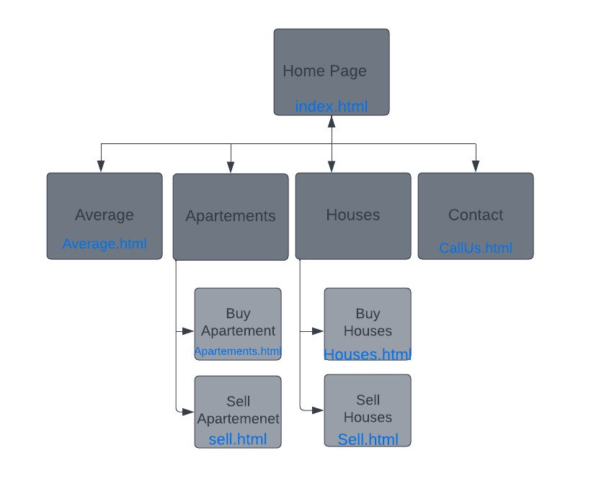

## 2. Look & Feel

## we use a basic design to look familiar with the users we use drop list

in some cases, and we use home link design pattern to make the transport in our website easier and we have a picture to show the user our products.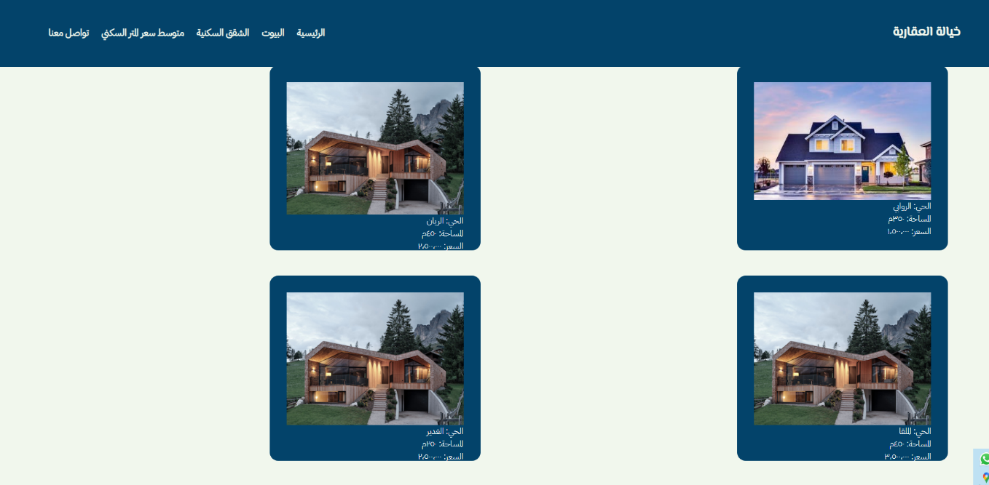we show you here how we grid the picture to look batter to the user and easier to find what he wants.

3. Dynamic Components

**Here we check if the information that the user provide is correct:**

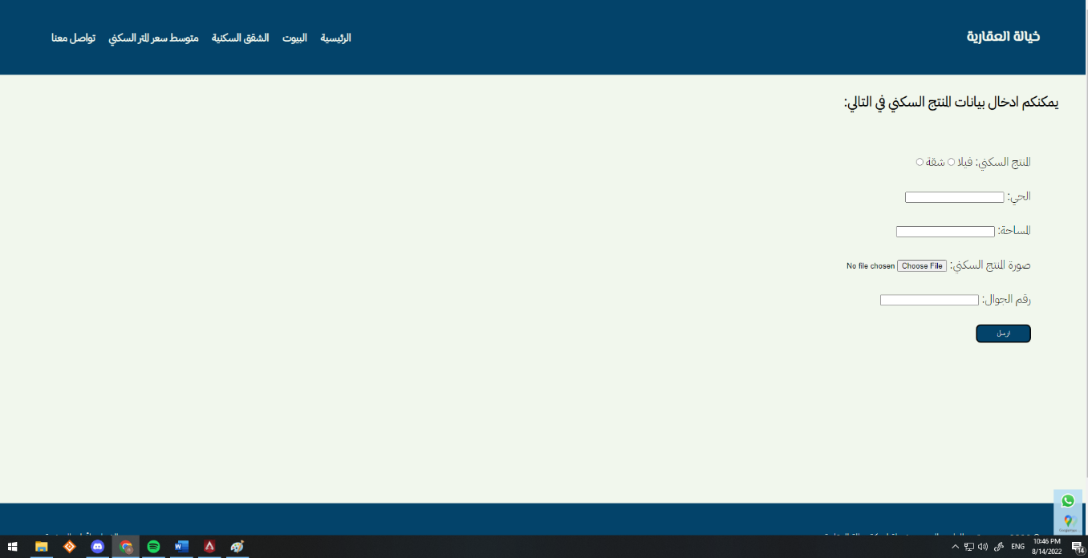

## 4. Business Logic

Our database includes the information of the user: E-mail, password, type of property, name of the neighborhood, space of the property, photo of his property and his phone number.

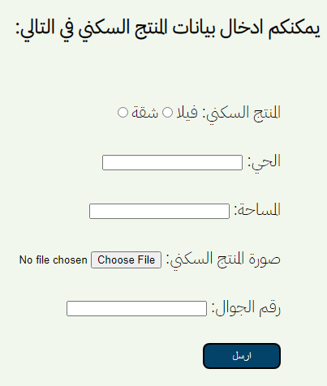

You can offer your property for sell in our website. Like it shows here. Then your property information goes to our database to show it to the buyers if they interest in your property, they can connect the real estate to buy it.

And we show the property that we have like this the neighborhood name, space, and price.

and we have sign up and sign in page we need just the E-mail and the password to sign up in our database .